3]
(i)
#include<stdio.h>
#include<stdlib.h>
struct Node{
int data;
struct Node *prev, *next;
};
struct Node* head = NULL;
struct Node* createNode(int x){
struct Node *n = (struct Node*) malloc(sizeof(struct Node));
n->data = x;
n->prev = n->next = NULL;
return n;
}
void insertEnd(int x){
struct Node *n = createNode(x);
if (head == NULL){
head = n;
return;
}
struct Node *t = head;
while (t->next != NULL)
t = t->next;
t->next = n;
n->prev = t;
}
int sizeDoubly(){
int count = 0;
struct Node *t = head;
while (t != NULL){
count++;
t = t->next;
}
return count;
}
int main(){
insertEnd(10);
insertEnd(20);
insertEnd(30);
insertEnd(40);
printf("Size of Doubly Linked List = %d\n", sizeDoubly());
return 0;
}
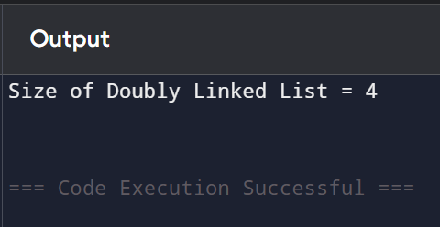

(ii)
#include<stdio.h>
#include<stdlib.h>
struct Node{
int data;
struct Node *next;
};
struct Node* head = NULL;
struct Node* createNode(int x){
struct Node *n = (struct Node*) malloc(sizeof(struct Node));
n->data = x;
n->next = NULL;
return n;
}
void insertEnd(int x){
struct Node *n = createNode(x);
if (head == NULL){
head = n;
n->next = head; // circular
return;
}
struct Node *t = head;
while (t->next != head)
t = t->next;
t->next = n;
n->next = head; // maintain circular link
}
int sizeCircular(){
if (head == NULL)
return 0;
int count = 0;
struct Node *t = head;
do{
count++;
t = t->next;
} while (t != head);
return count;
}
int main(){
insertEnd(5);
insertEnd(10);
insertEnd(15);
insertEnd(20);
printf("Size of Circular Linked List = %d\n", sizeCircular());
return 0;
}
